Context / Problem Statement:

Big Mountain Resort has recently installed an additional chair lift to help increase the distribution of visitors across the mountain. This additional chair increases their operating costs by $1,540,000 this season. Every year about 350,000 people ski or snowboard at Big Mountain. This business profit margin is 9.2% and the investors would like to keep it there. The business is eager to get your recommendations on recouping the increased operating costs from the new chair this season.

Process Methodology Followed:

Initially in the Model ,

* We Observed and cleaned the given dataset
* Filled in the **Nan** values using fill method as mean
* Dropped unnecessary columns
* Scaled the data using Transform
* Made dummy variables for categorical variables
* Split the dataset available into training and testing set with the ratio 75:25
* Used Linear Regression Algorithm to fit and Predict Values Respectively , also Variable Coefficients were Calculated.
* Checked model error by calculating mean absolute error and Variance of the Model.
* Lastly we visualized the results by using Scatter and Regressor Plots.

Key Variables Involved In the above case study:

* Region/State where resort is located
* AdultWeekday Ticket Prices.
* AdultWeekend Ticket Prices.
* No of Days when resort is open and predicted days.

Model Description

To Start with initially, columns Name and Adultweekend were dropped (Variable X), with variable to predict as AdultWeekend ticket prices (variable as Y) coefficients were calculated of independent variables along with mean error and variance of the initial Model.

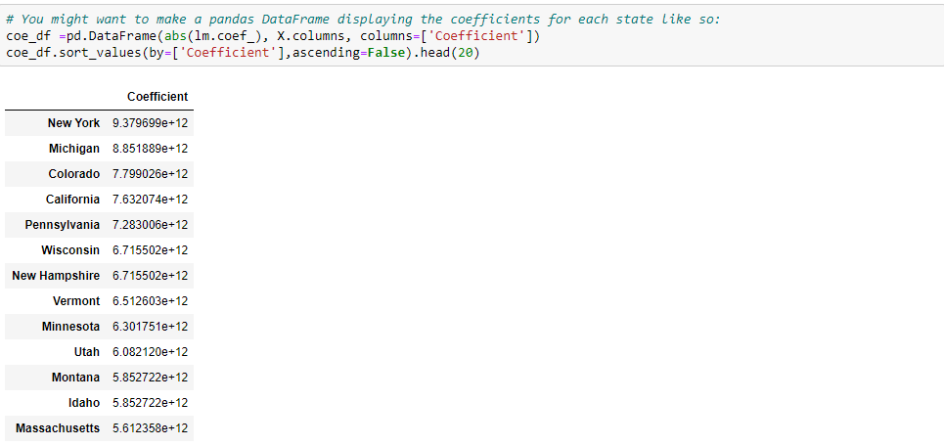

Big Mountain Resort Located

As seen above Coefficient is High for states which states in the given model location of Resort is the key parameter for profit consideration , However as Location of Big Mountain Resort is fixed and located in Minnesota County. Therefore in our next model we drop Region Parameter from our analysis and rerun the model again.

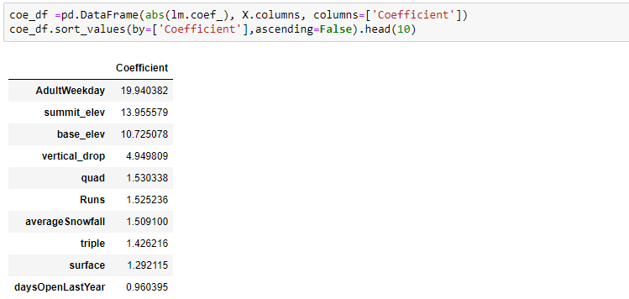

We observe that after dropping state columns AdultWeekday and Adultweekend ticket prices have higher Coefficients and hence our focused should be on these to increase profitability further for columns summit_elev and base_elev and vertical drop columns are again fixed for the given location and resort hence these too should not be considered in our analysis.

Model Summary Table:

|  |  |  |  |  |  |  |
| --- | --- | --- | --- | --- | --- | --- |
| Model | Y Variable | Predicted Value | Actual Value | Mean error | Variance | Features Drop |
| 1 | AdultWeekend | 88 | 81 | 5.51 | 0.91 | 'state','summit_elev','base_elev',  Adultweekend,vertical Drop |
| 2 | AdultWeekday | 74 | 81 | 5.83 | 0.92 | state','summit_elev','base_elev',  Adultweekday,vertical Drop |
| 3 | Days open | 129 | 123 | 13.66 | 0.36 | state','summit_elev','base_elev',  daysopen,vertical Drop |
| 4 | Projected Days open | 130 | 123 | 13.31 | 0.011 | state','summit_elev','base_elev',  projecteddays,vertical Drop |

Conclusions:

* As seen in model results more emphasis should be laid on increasing the prices of tickets for the Big Mountain Resort on weekends also prices can be increased on weekdays too.
* Furthermore by opening the resorts on more days will result in more profitability.